

# ***User Manual***

**Smart Home: Household Appliance usage Recommender and Monitoring System (HARMS)**

**By**

Salma Abdullah Alomar (217019858)

Nabaa Jafar Busbaih (217017935)

Maryam Hussain Alashwan (217035462)

**Supervised by**

Mr. Conrado P.Vizcarra

**Committee Members**

Dr. Nora Alkhaldi

Eng. Madiha Anjum

**Kingdom of Saudi Arabia**

**Ministry of Education**

**King Faisal University**

**College of Computer Sciences & Information Technology**

**1.Download and installation**

**A. download and install Python:**

**Step 1) To download and install Python, visit the official website of Python https://www.python.org/downloads/ and choose your version and the right Operation system (OS). Now, we will download Windows OS and we have chosen Python version 3.6.3.**

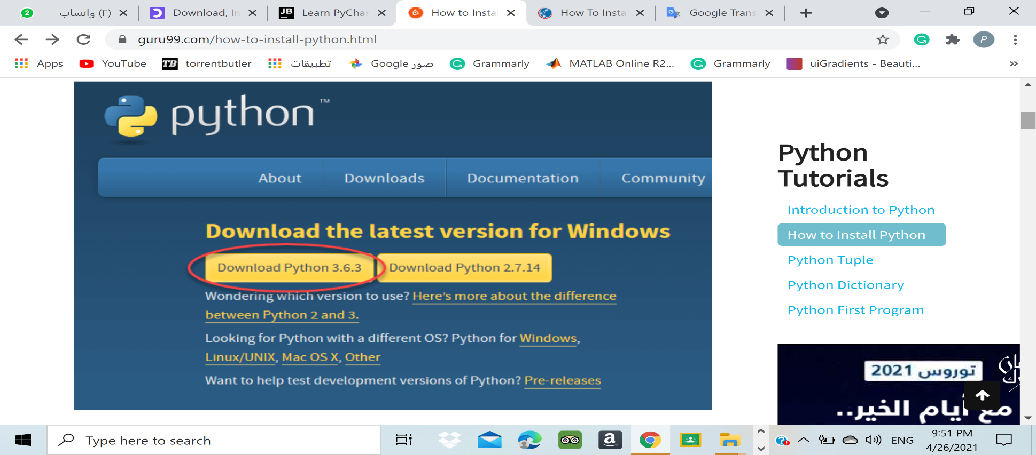

**Step 2)** Once the download is completed, run the .exe file to install Python. Now click on Install Now.

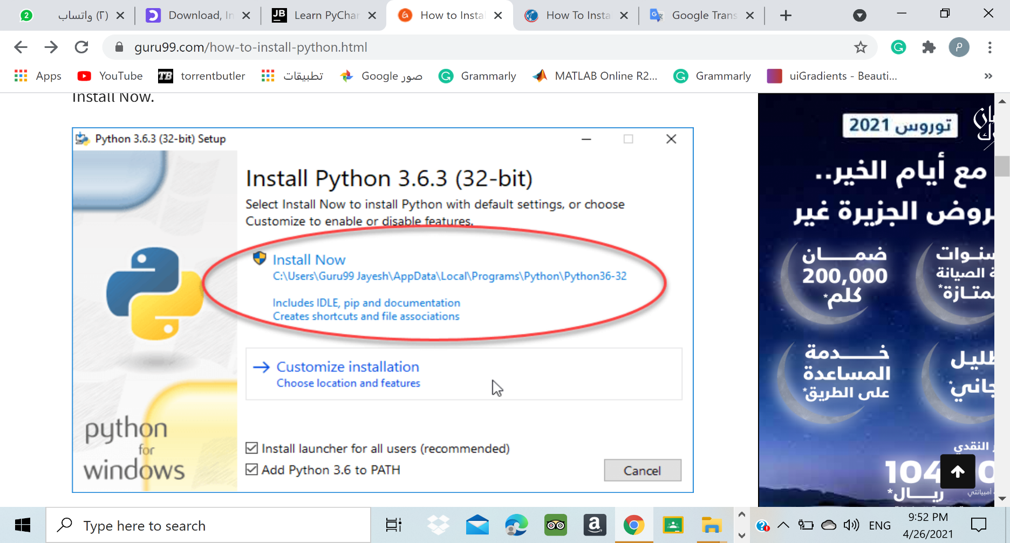

**Step 3)** You can see Python is installing.

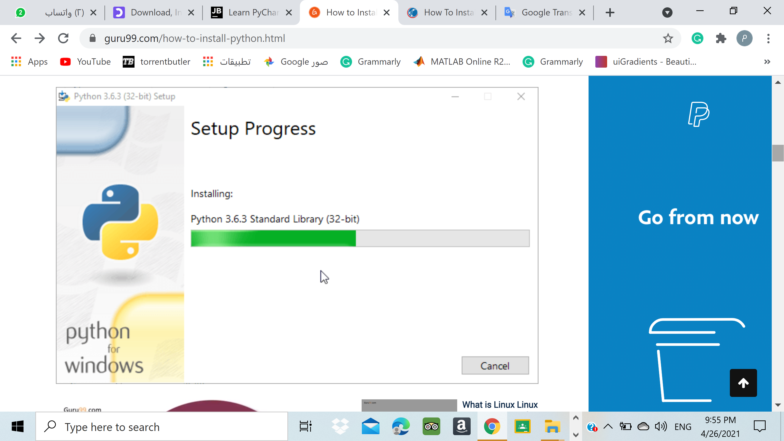

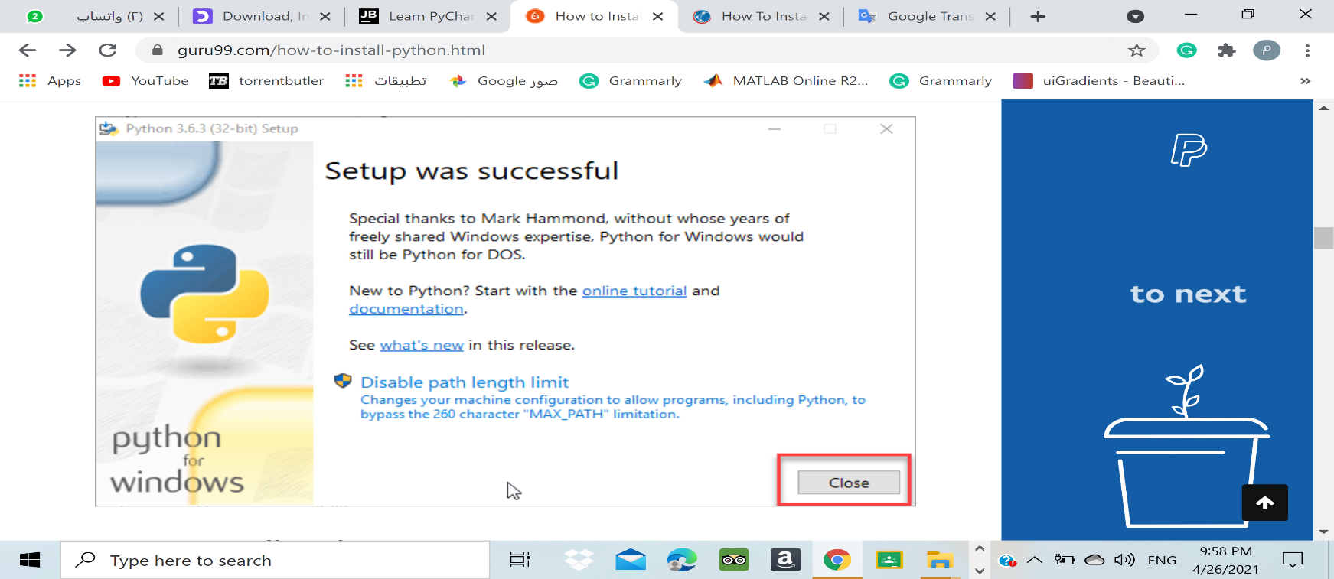**Step 4)** When it finishes, click on "Close".

**B. download and install PyCharm:**

**Step 1)** To download PyCharm visit the website <https://www.jetbrains.com/pycharm/download/> and Click the "DOWNLOAD" link under the Community Section.

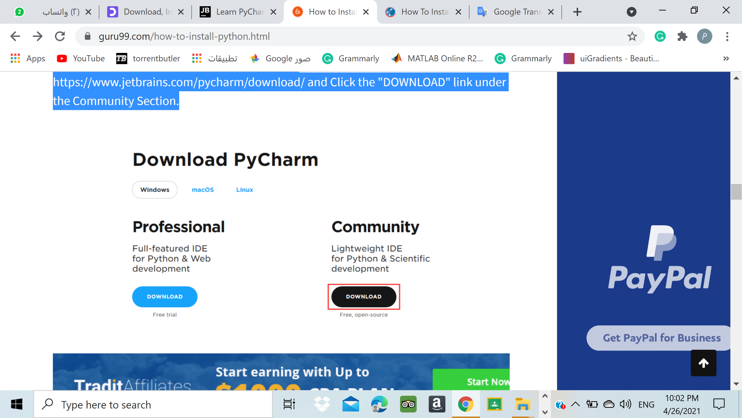

**Step 2)** Once the download is complete, run the exe for install PyCharm. The setup wizard should have started. Click “Next”.

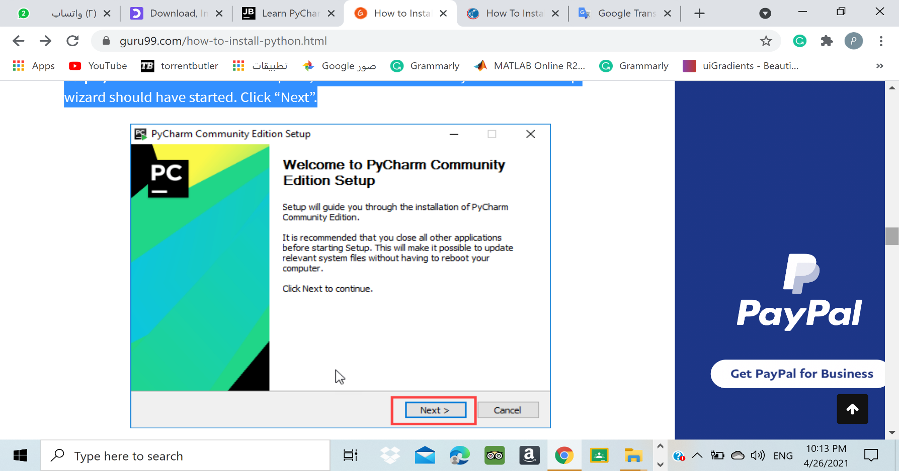

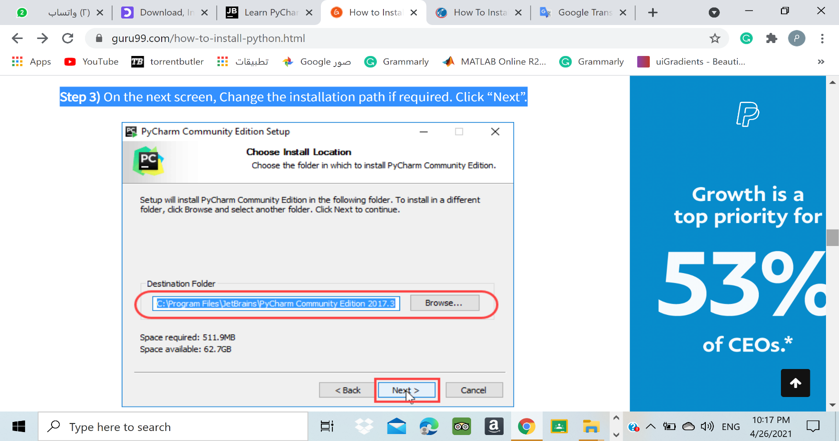**Step 3)** On the next screen, Change the installation path if required. Click “Next”.

**Step 4)** On the next screen, you can create a desktop shortcut if you want and click on “Next”.

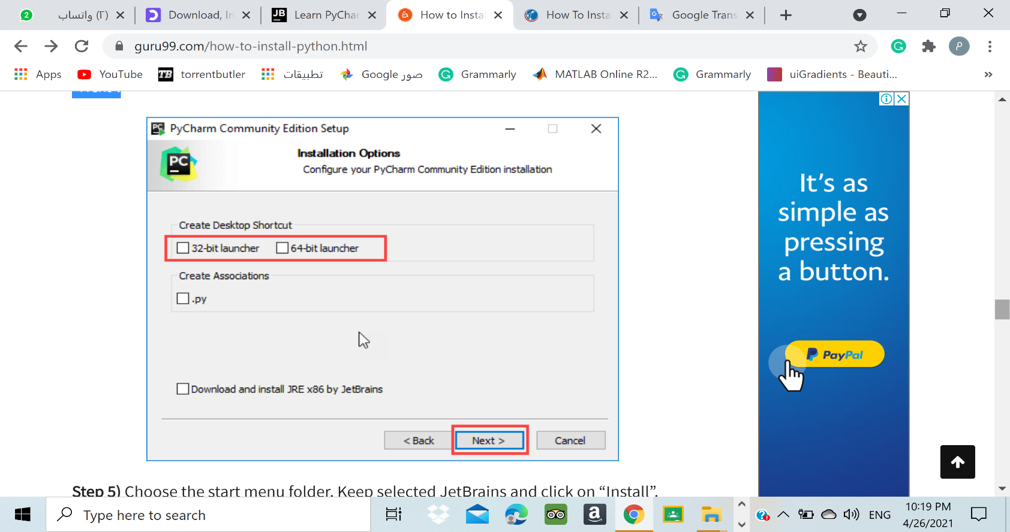

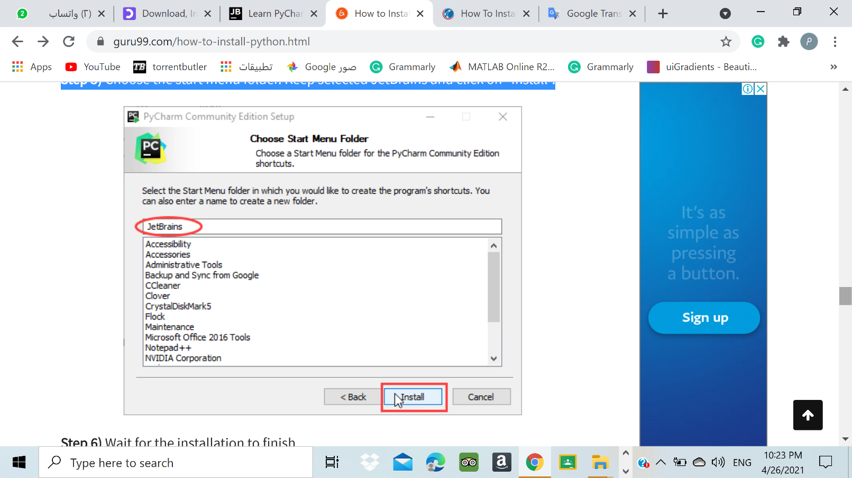**Step 5)** Choose the start menu folder. Keep selected JetBrains and click on “Install”.

**Step 6)** Wait for the installation to finish.

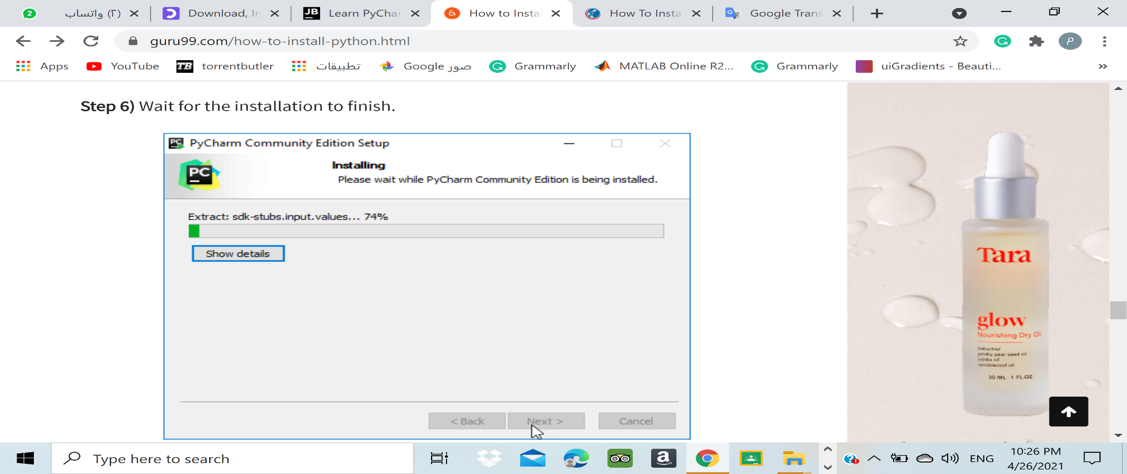

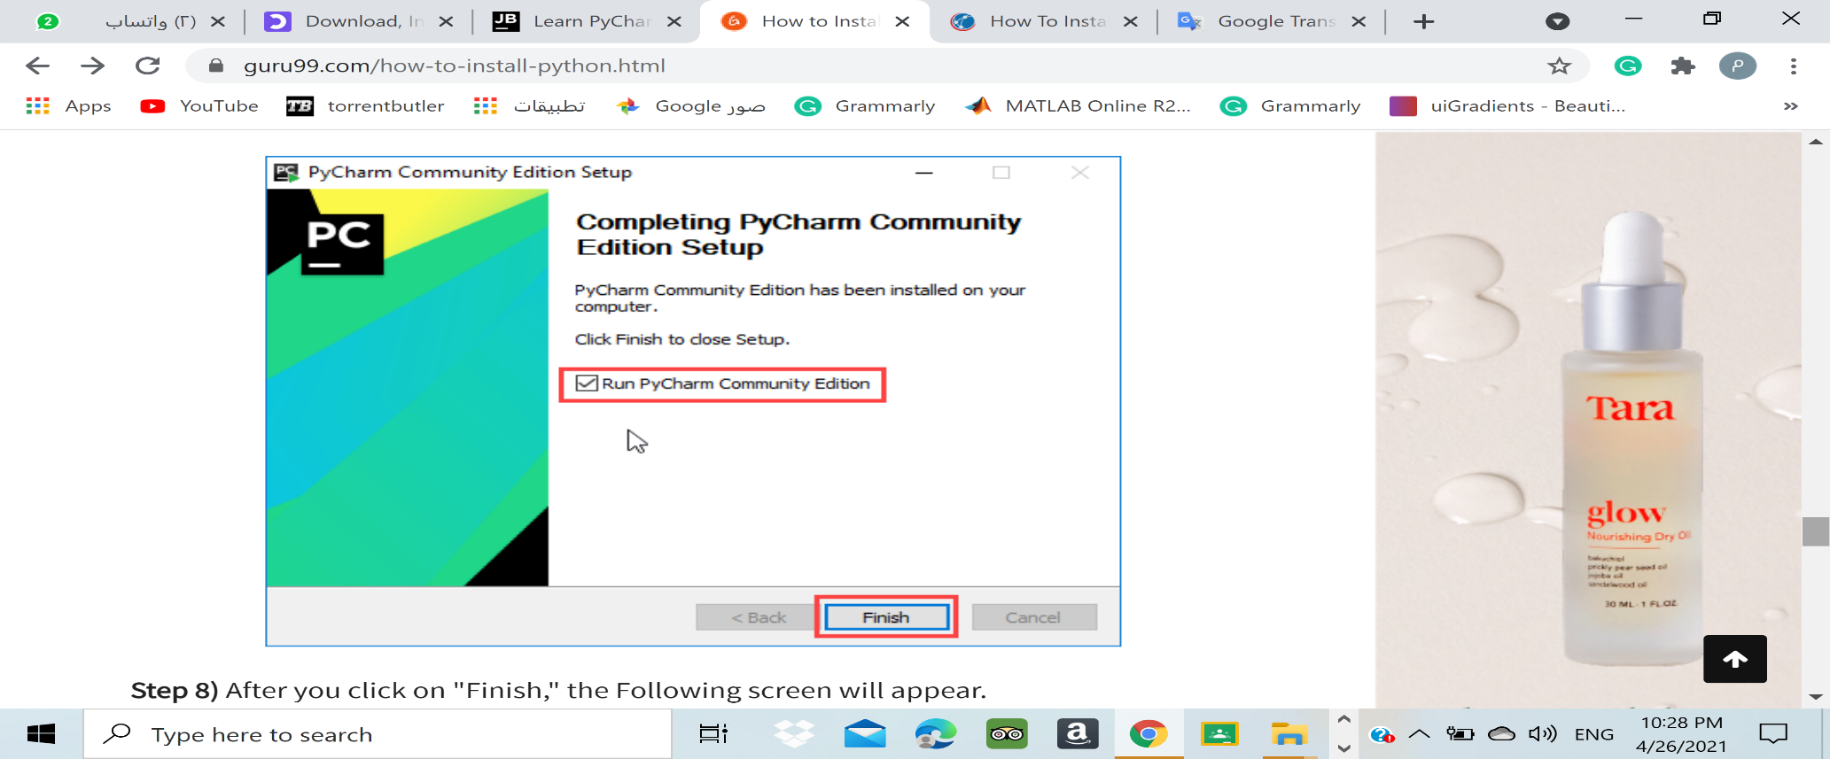**Step 7)** Once installation finished, you should receive a message screen that PyCharm is installed. If you want to run it, click the “Run PyCharm Community Edition” box first and click “Finish”.

**Step 8)**After you click on "Finish," the Following screen will appear.

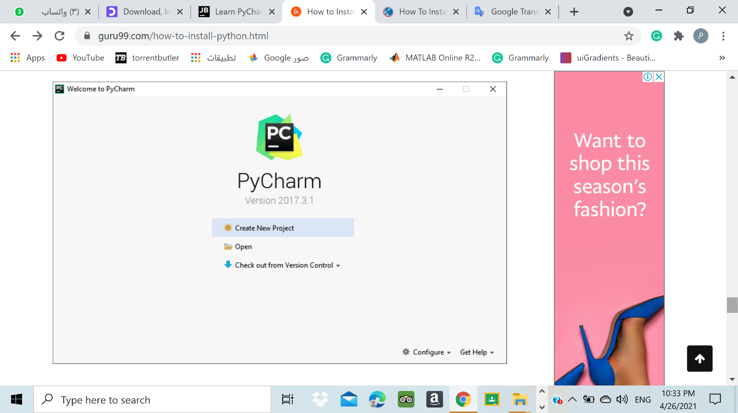

**C. download and install XAMPP:**

**Step 1)** Download the XAMPP from the [Apache Friends](http://www.apachefriends.org/de/download.html) website. The website provides different Versions with PHP 5.5, 5.6, or 7.

**Step 2)** Once the download is complete, run the exe by double clicking  on the file with the ending [.exe](https://www.ionos.com/digitalguide/server/know-how/exe-file/).

**Step 3)** Pause any antivirus software until all XAMPP components have successfully been installed because an active antivirus program can negatively affect the installation process.

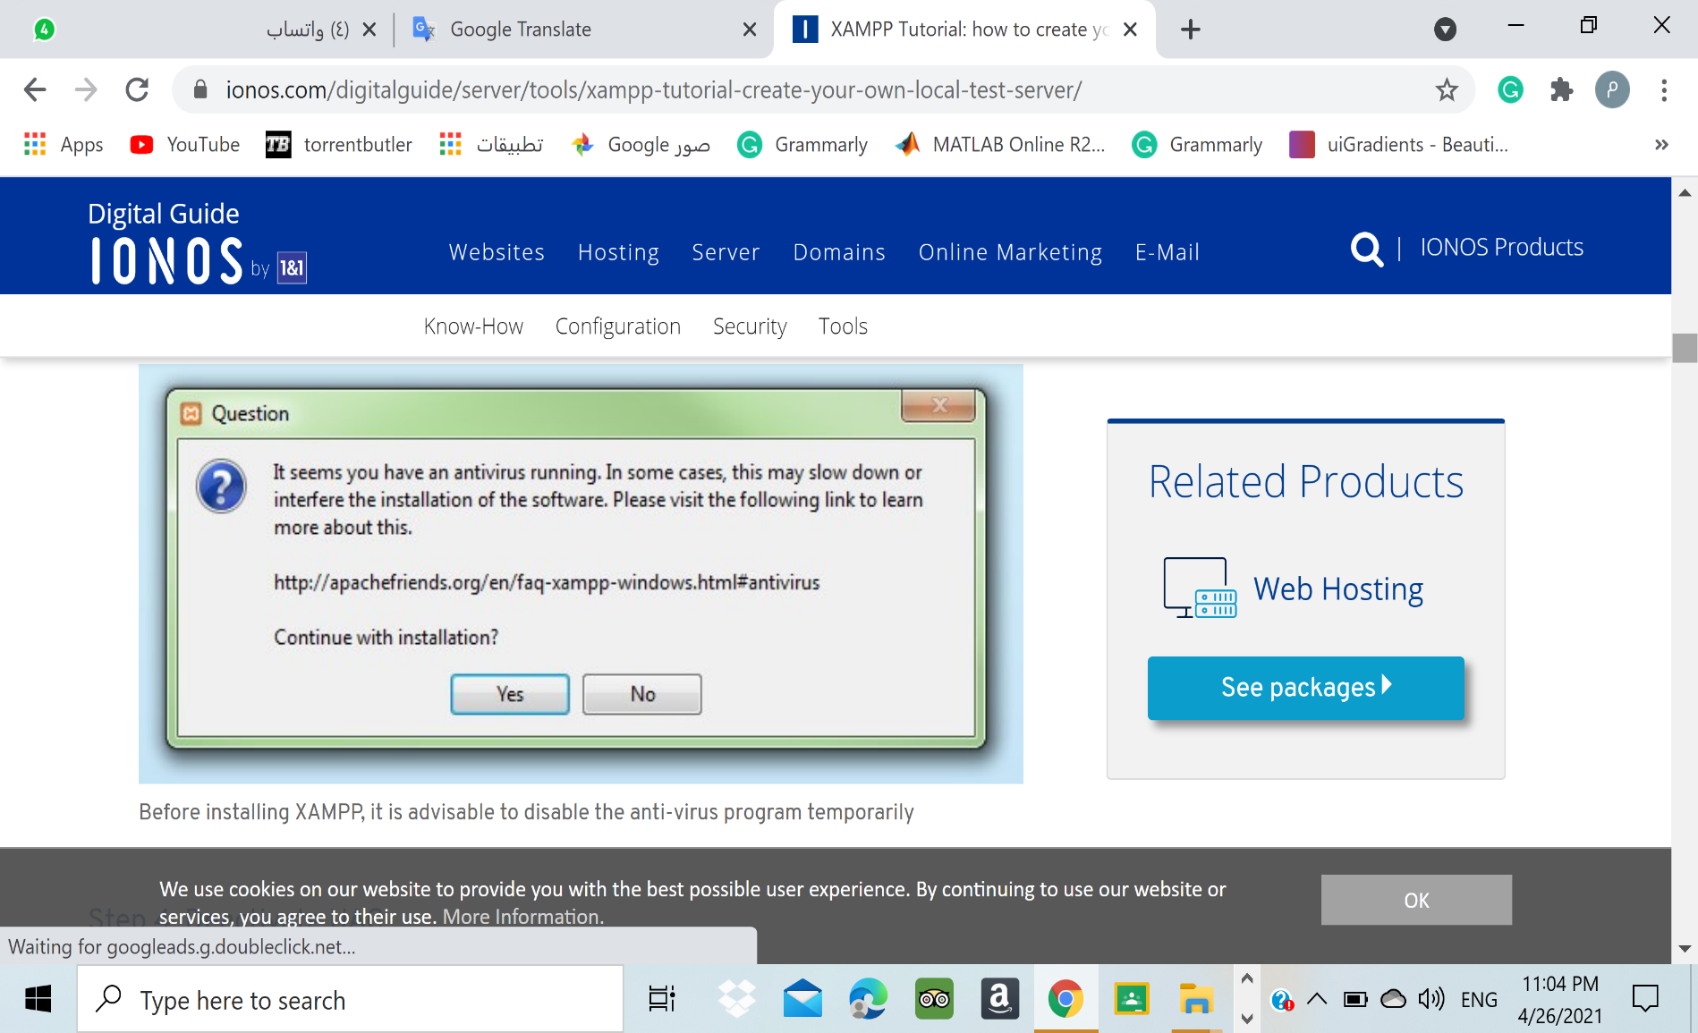

**Step 4)** Disable the User Account Control (UAC) because it can interfere with the XAMPP installation because it limits writing access to the C: drive.  To find out how to turn off your UAC, head to the [Microsoft Windows support pages](https://support.microsoft.com/en-us/help/17228/windows-protect-my-pc-from-viruses) 🡪 [https://support.microsoft.com/en-us/windows/protect-my-pc-from-viruses-b2025ed1-02d5-1e87-ba5f-71999008e026#](https://support.microsoft.com/en-us/windows/protect-my-pc-from-viruses-b2025ed1-02d5-1e87-ba5f-71999008e026).

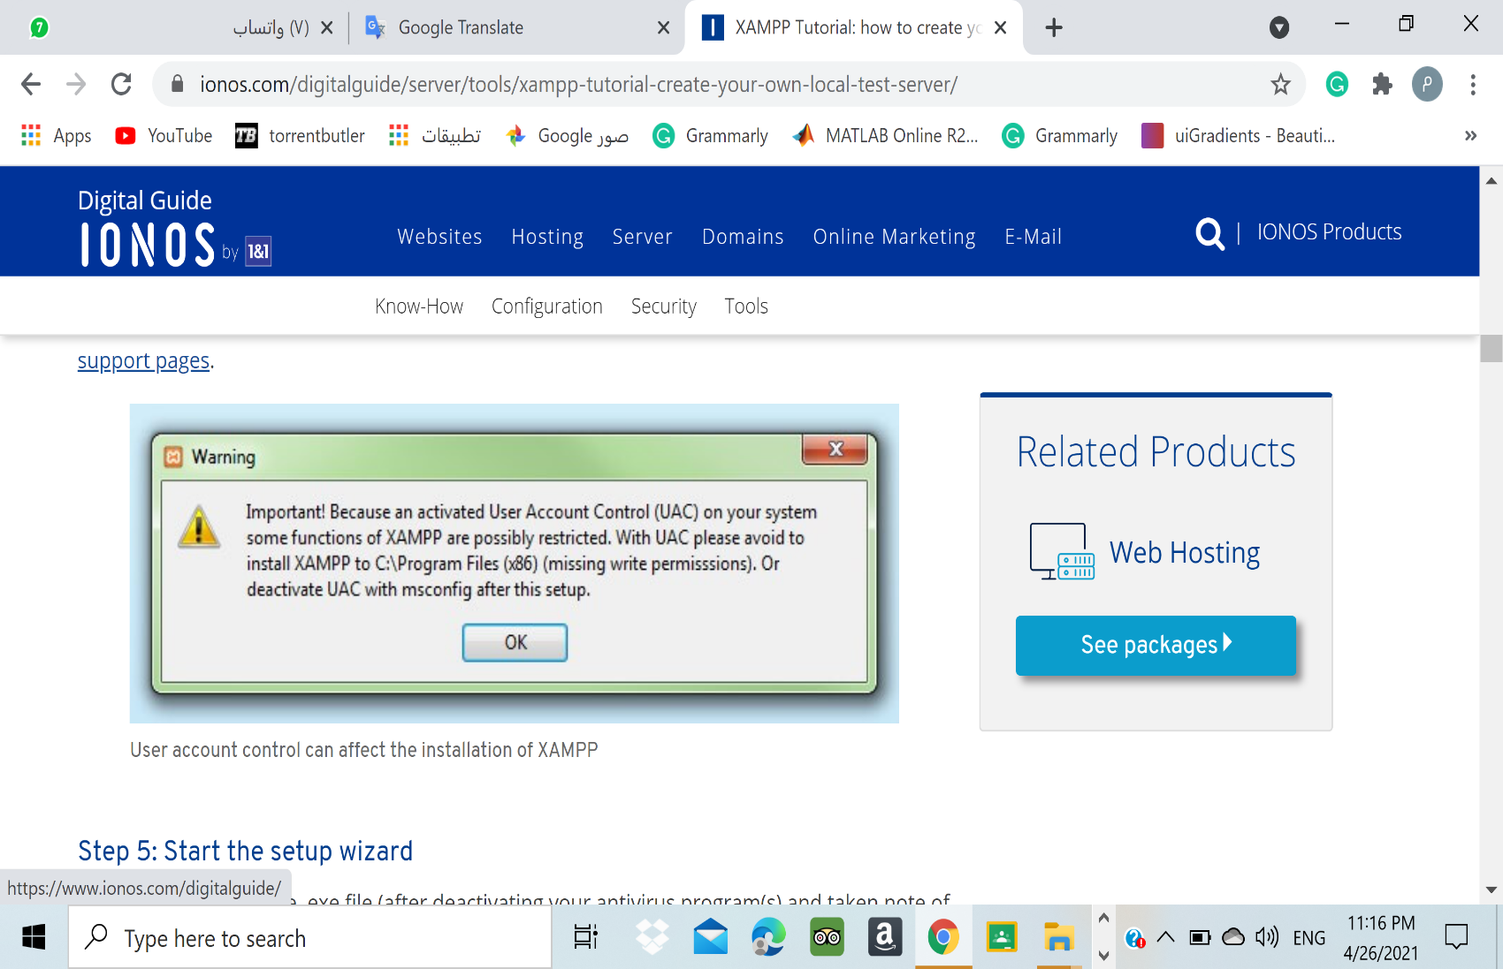

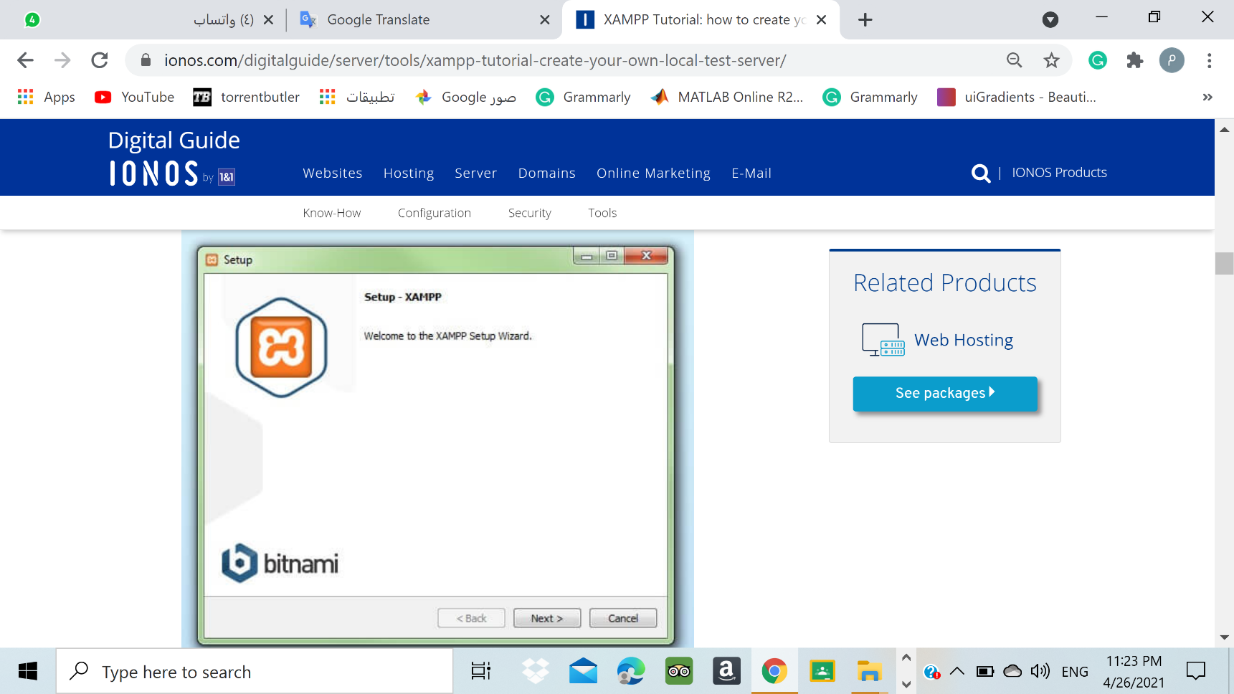**Step 5)** Open the .exe file. Click on ‘Next’ to configure the installation settings.

**Step 6)** Choose software components.  But for a full local test server, we recommend you install using the standard setup and all available components. After making your choice, click ‘Next’.

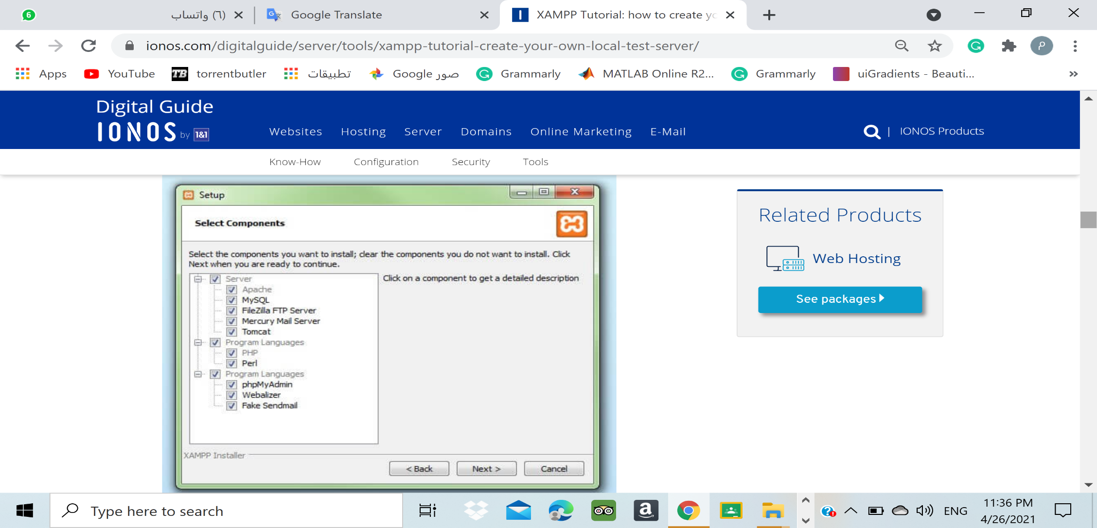

#### Step 7) Choose the installation directory.

#### 

#### Step 8) Start the installation process.

#### 

#### Step 9) Block Windows Firewall because it interrupts the installation process to block some components of the XAMPP.

#### Step 10) Once the installed is complete. you can close the setup wizard by clicking on ‘Finish’.

#### 

## The XAMPP Control Panel

🡪To open the Control Panel, go to 🡪 C:\xampp and double click on " xampp-control " and the following window will appear.

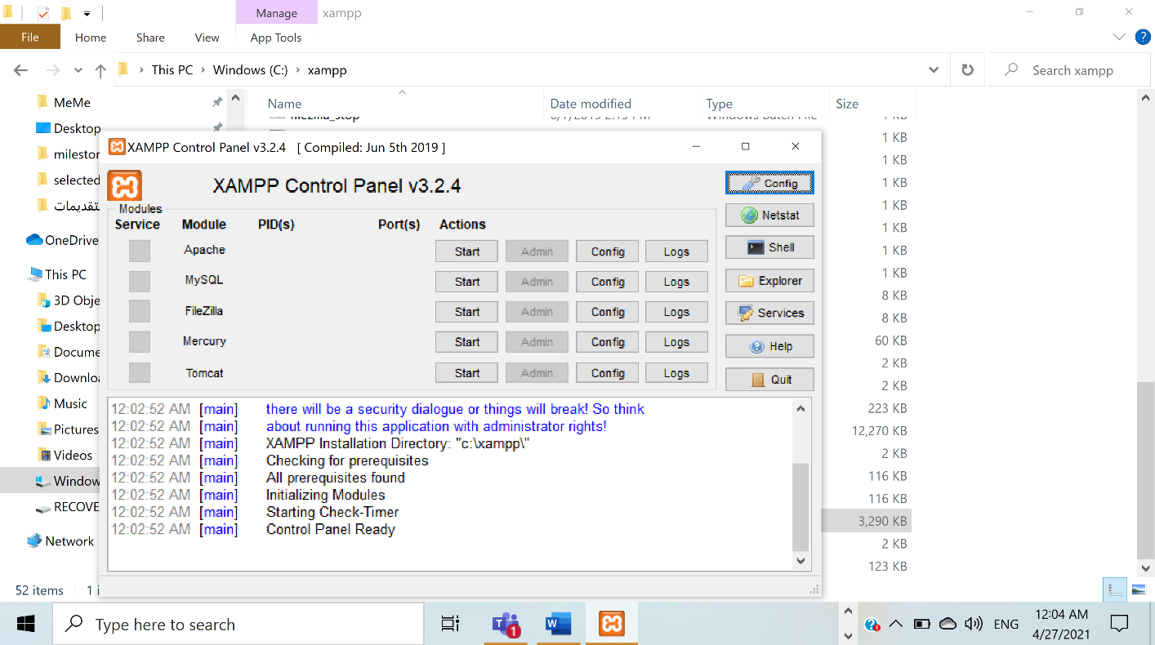

🡪Start the Apache and MySQL by click the "Start" button.

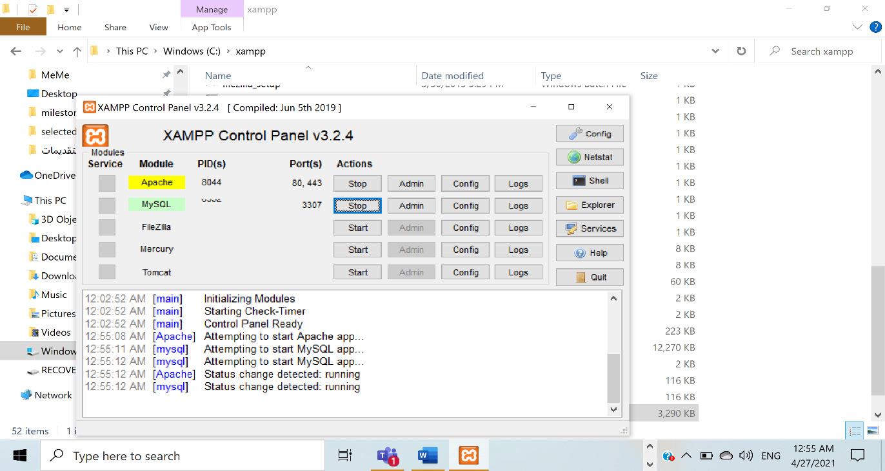

**D. download and install** **Visual Studio:**

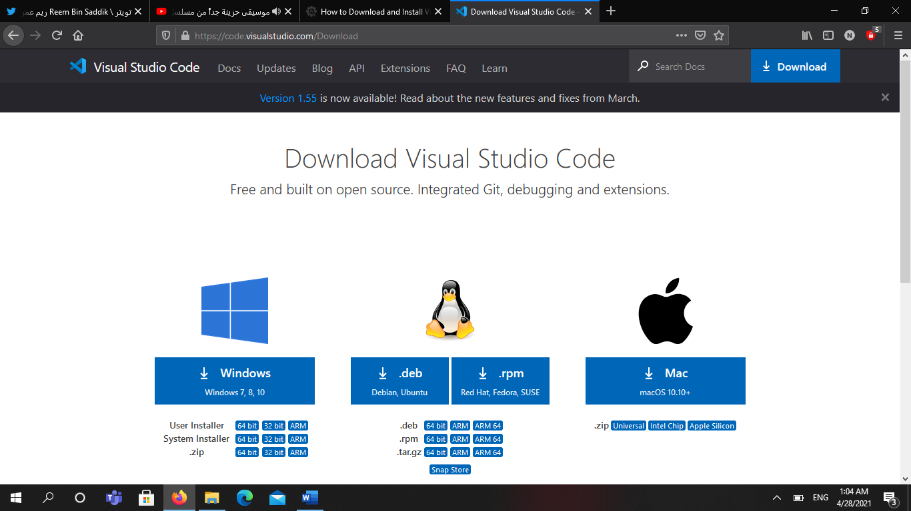🡪You can download Visual Studio code from URL “[***https://code.visualstudio.com/download***](https://code.visualstudio.com/download)” by selecting the right platform:

🡪Follow the below steps (shown in gif file) to install the VS Code on macOS:



🡪Follow the below steps (shown in gif file) to install the VS Code on windows:



🡪 Accept the agreement and click on next.

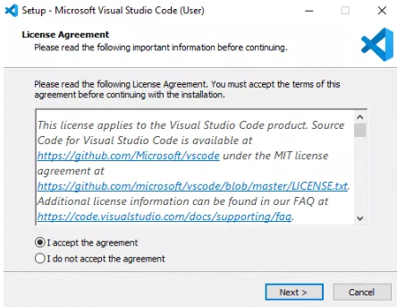

🡪Click "Next"

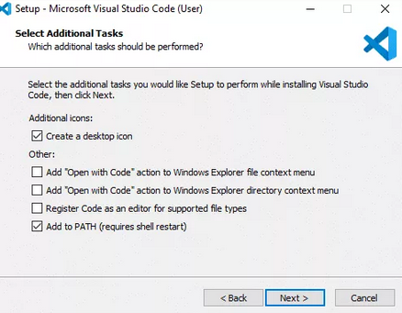

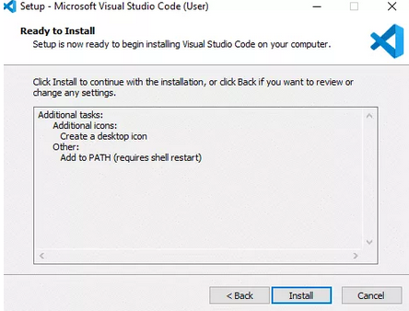🡪Click "Install".

🡪 Once the installed is complete. you can close the setup wizard by clicking on ‘Finish’.

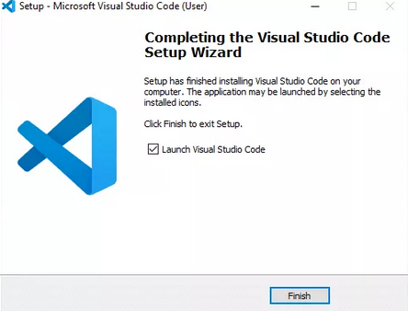

**F. download and install** **Android Studio:**

🡪To download the Android Studio, visit the official [Android Studio](https://developer.android.com/studio/) website in your web browser.

🡪Click on the "Download Android Studio" option

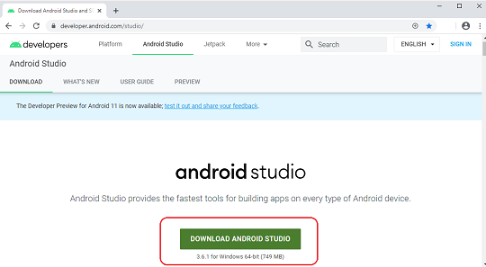

🡪Double click on the downloaded "Android Studio-ide.exe" file.

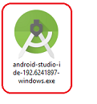

🡪click "Next"

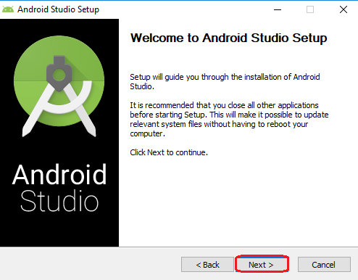

🡪Next

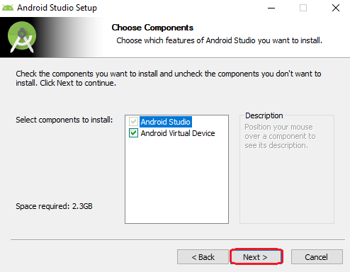

🡪 Choose the installation directory.

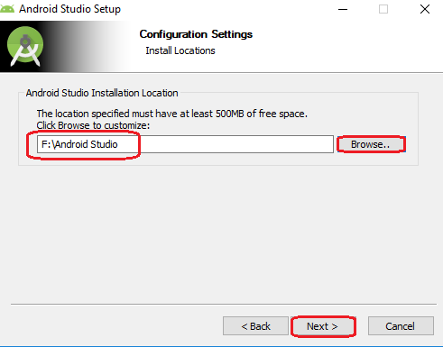

🡪Choose Start Folder, and click "Install"

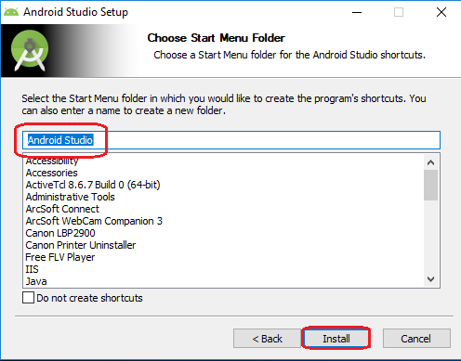

🡪click "Next"

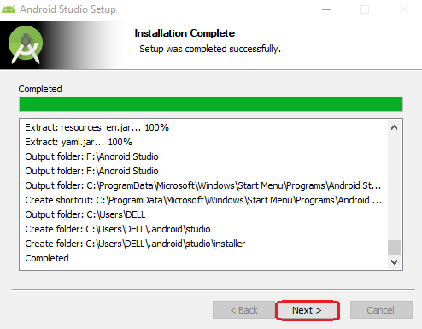

* Click "Finish"

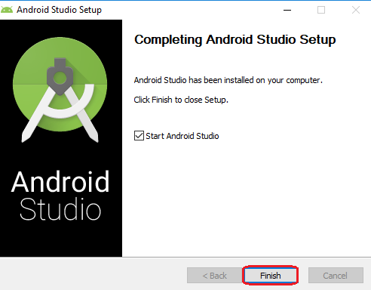

🡪"Android Studio Setup Wizard" will appear on the screen with the welcome wizard. Click on the "Next" button.

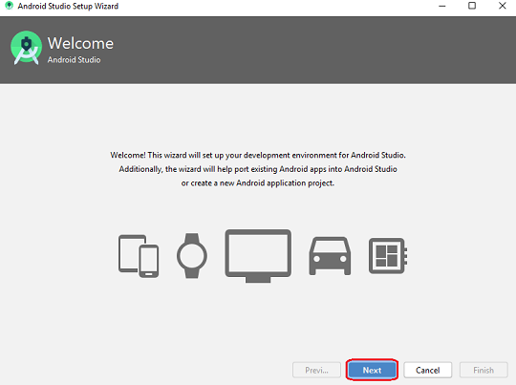

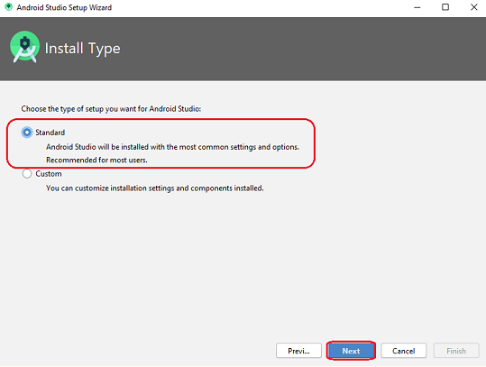🡪Choose Standard. Click "Next"

🡪Select UI Theme. Click "Next"

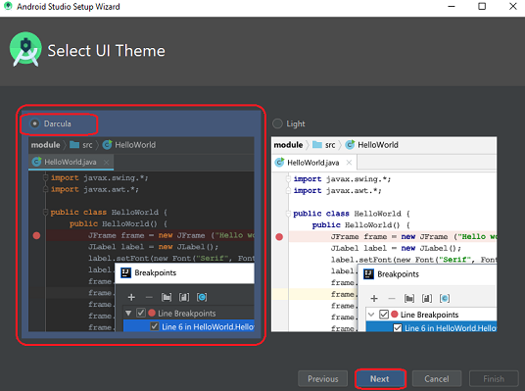

🡪Click "Finish"

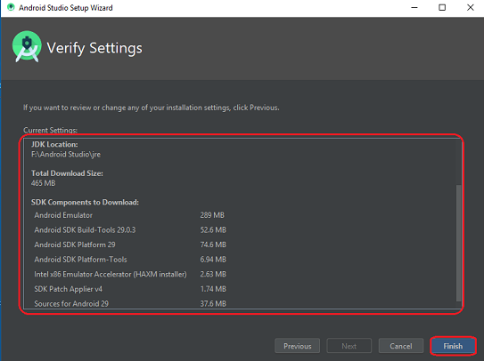

🡪 Once the download is complete, Then click finish.

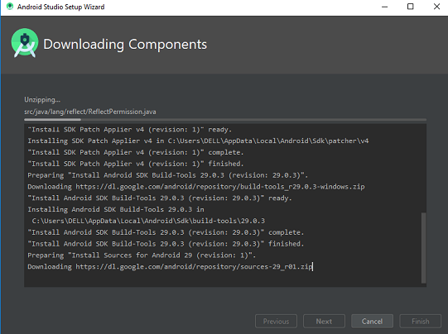

* Set up Raspberry Pi

🡪inserted the microSD card into the USB card reader.

🡪Connected the card reader to the computer.

🡪Downloaded SD Formatter .

🡪Downloaded the ZIP file of Raspbian.

🡪Use Etcher to flash the OS of raspberry pi “Raspbian” to the SD card.

🡪After that, we inserted the microSD card into the Raspberry Pi.

🡪Plugged the USB keyboard and mouse into one of the USB ports.

🡪Plugged the HDMI cable into the monitor or TV and another end of the cable into the Raspberry Pi HDMI port.

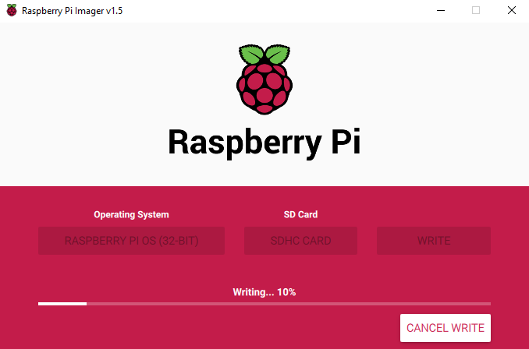🡪Connected the power supply to the Raspberry Pi.

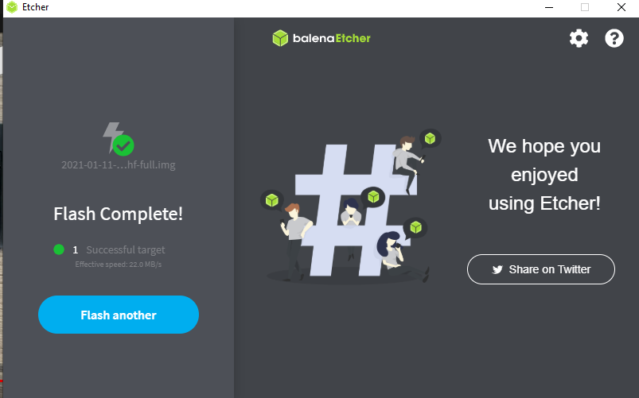

## **2.Load the project**

## **Loading the "HARMS_Project" file**

🡪Download the " HARMS_Project " Zip file

Extract the file inside" htdocs" folder 🡪 C:\xampp\htdocs

🡪In the control panel open the Apache(http.conf) file in "Config" button

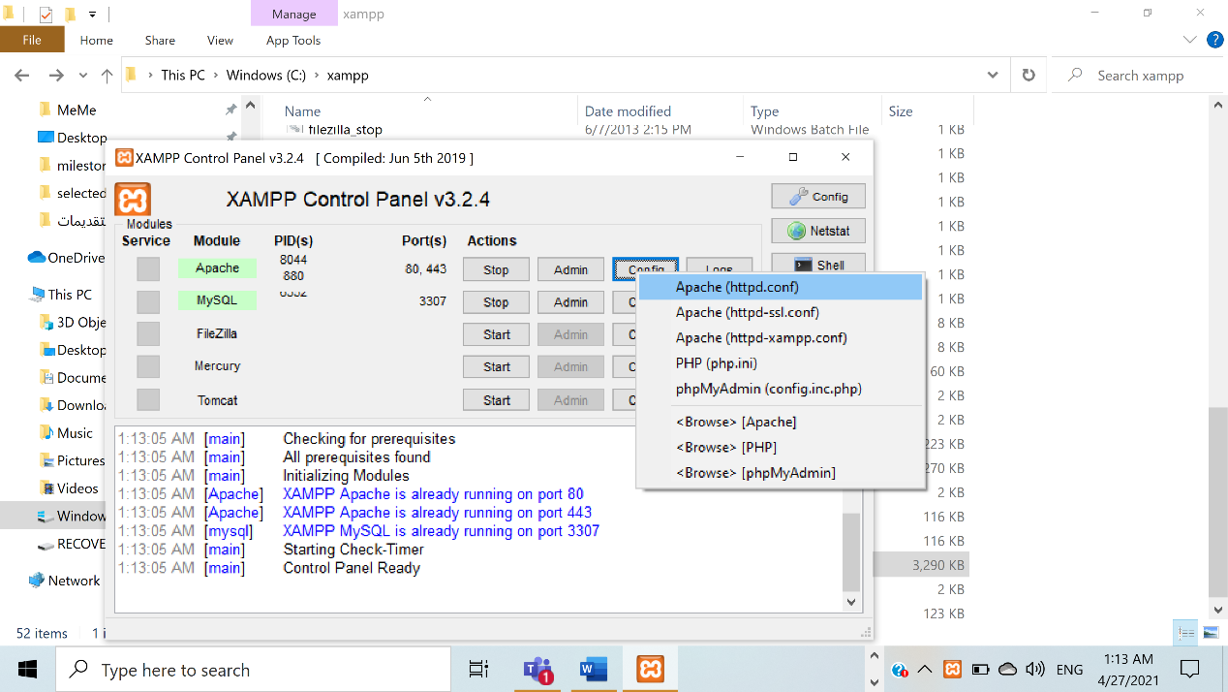

🡪Add these two lines in the end of the (http.conf) file. These two lines are necessary to run the python files to run .py files that contains some html tags inside the XAMPP

AddHandler cgi-script .py

ScriptInterpreterSource Registry-Strict

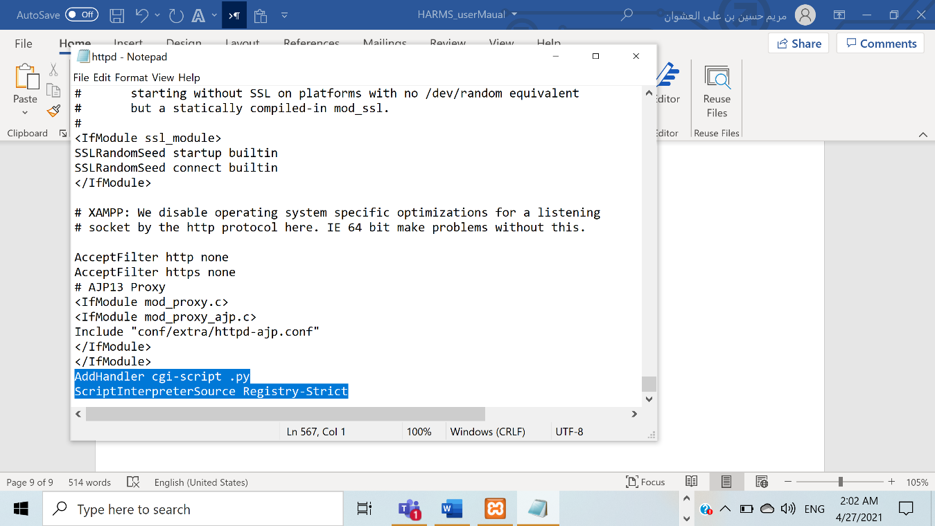

🡪 In the first line of .py file that contains some html tags you need to add the path for you python as below.

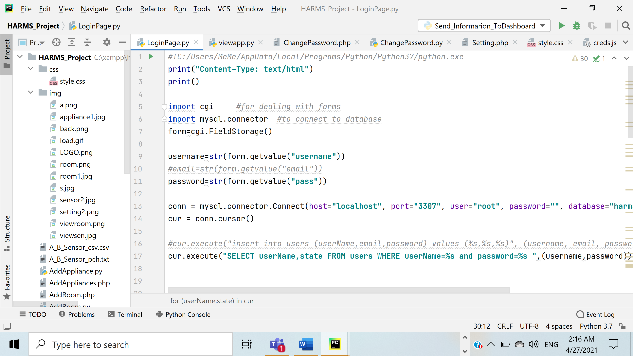

🡪If you want to edit the code, you can open it using PyCharm. Follow the steps below.

**Step1)** Open PyCharm and go to file tab. Then, choose open.

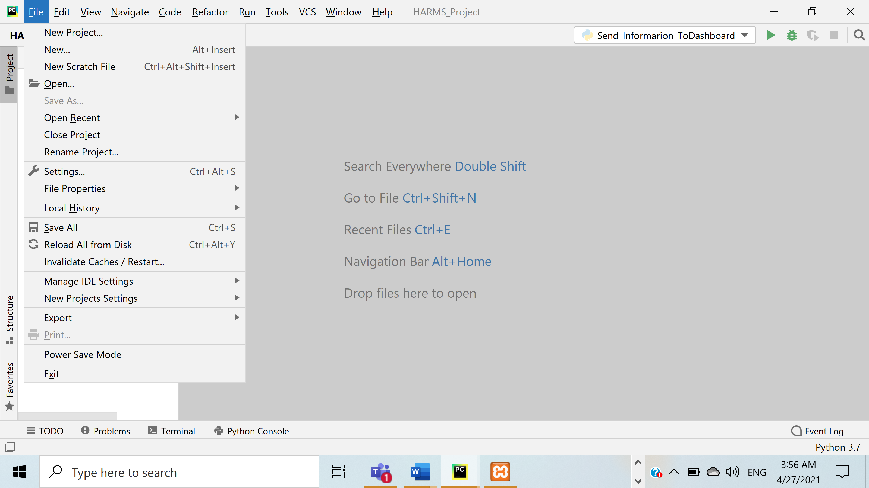

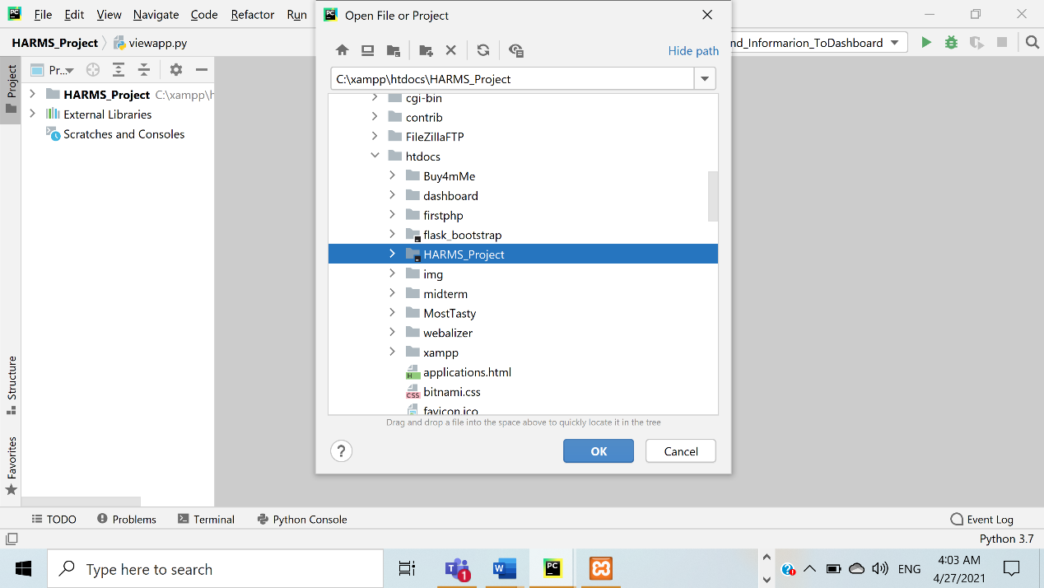**Step 2)** Navigate and choose "HARMS_Project" file. Then, click "ok"

## **B. Loading the database in PhpMyAdmin**

🡪Download "harms_db.sql" file

🡪Click on the Admin button of your Apache server to go to the web address of your web server after starting the Apache and MySQL

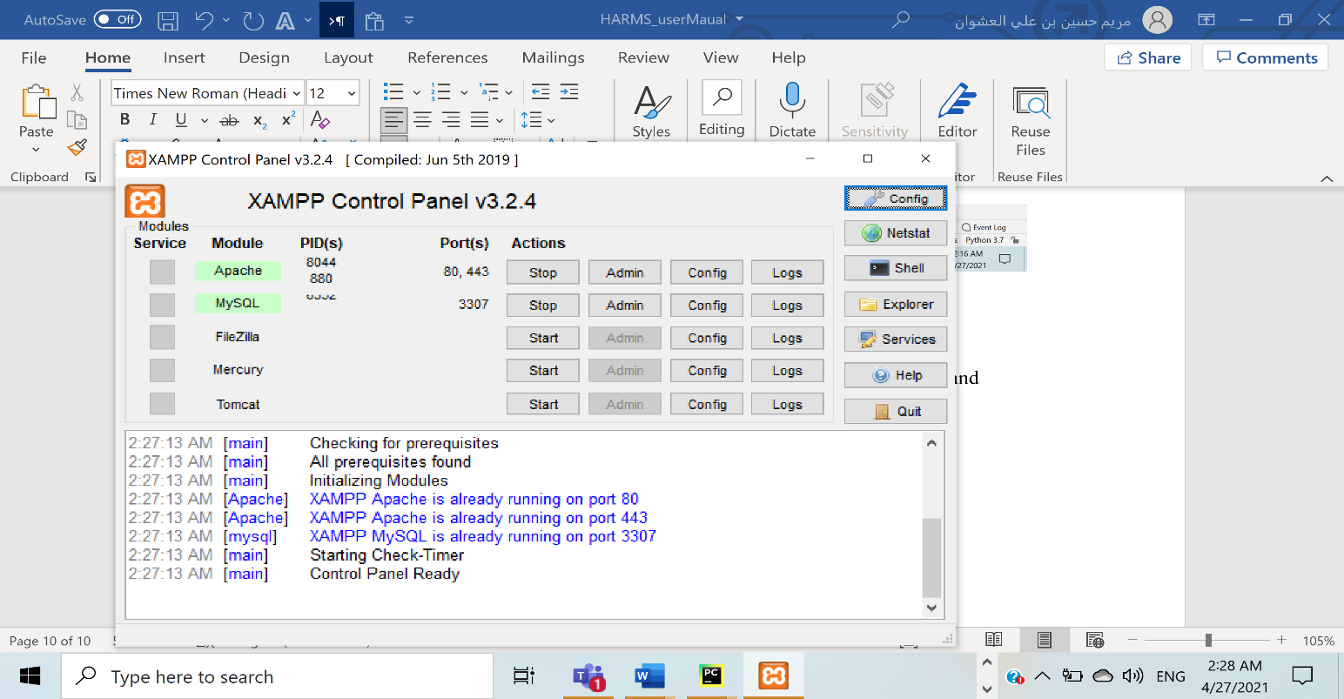

**1**

**2**

🡪Now, you can manage the databases of your web projects that you’re testing on your XAMPP. **Alternatively**, you can reach the administration section of your MySQL database via [localhost](https://www.ionos.com/digitalguide/server/know-how/localhost/)/phpmyadmin/.

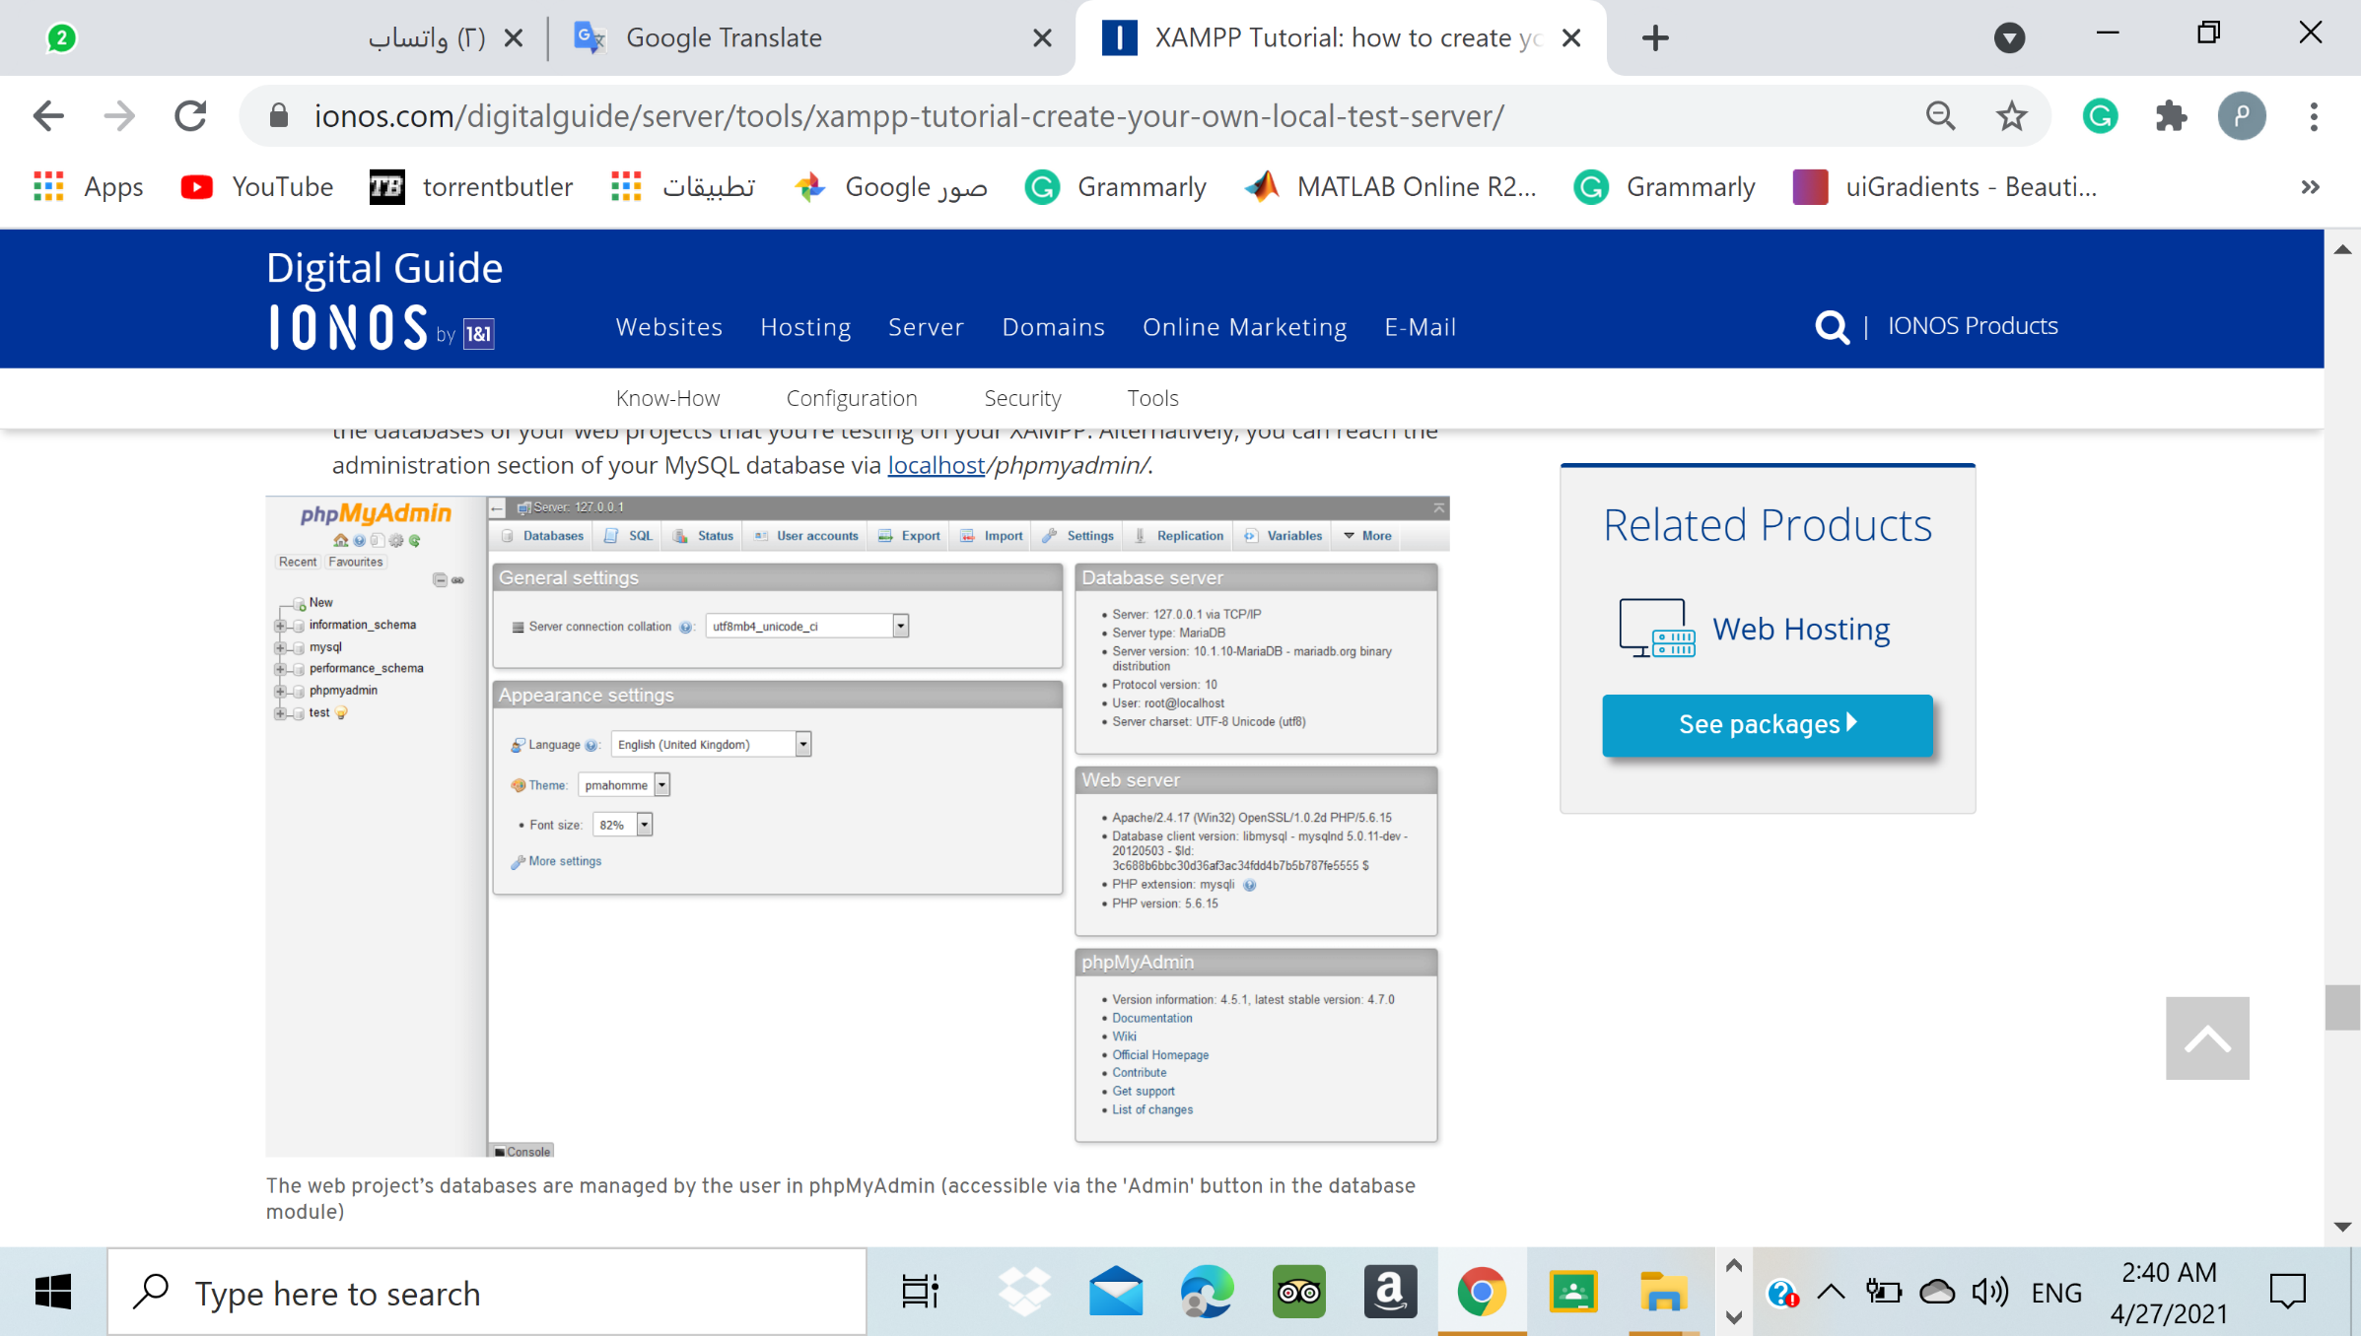

🡪Create database with name " harms_db" (same name of the downloaded database)

By clicking new

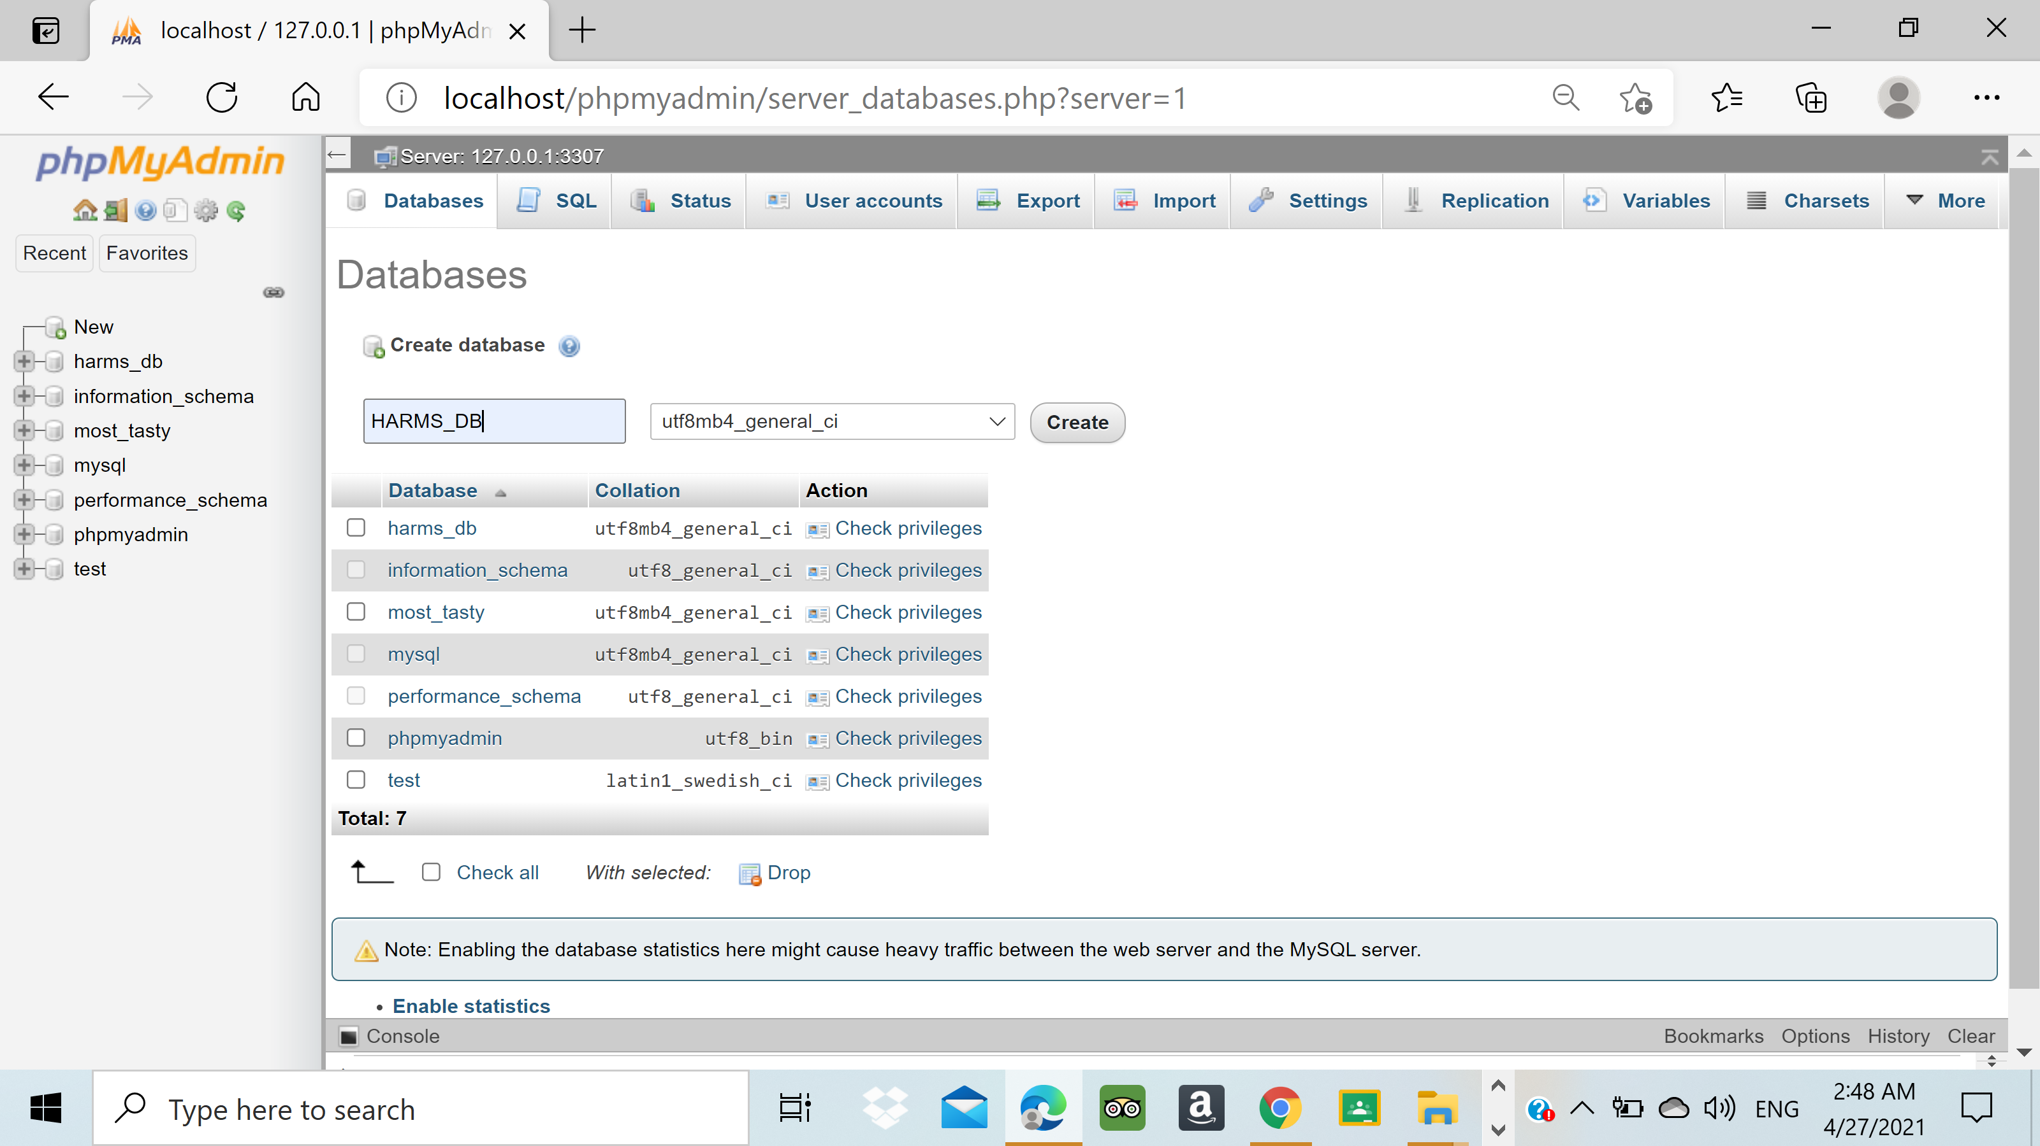

2

3

1

🡪Go to import.

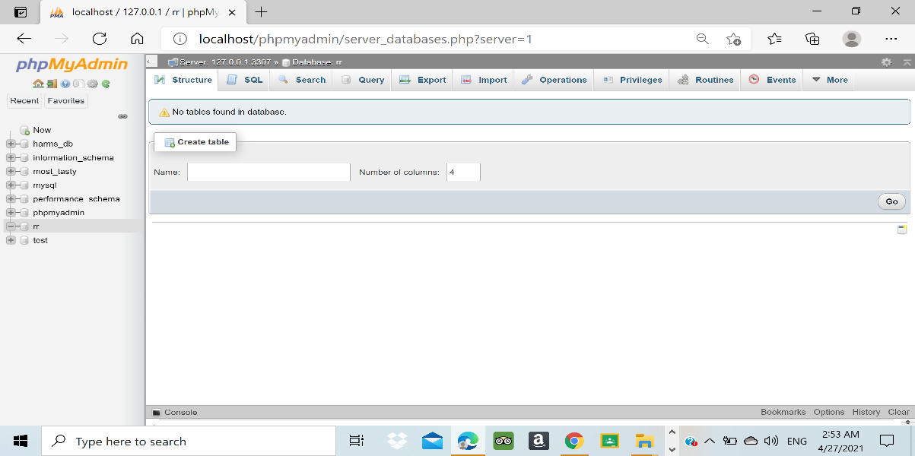

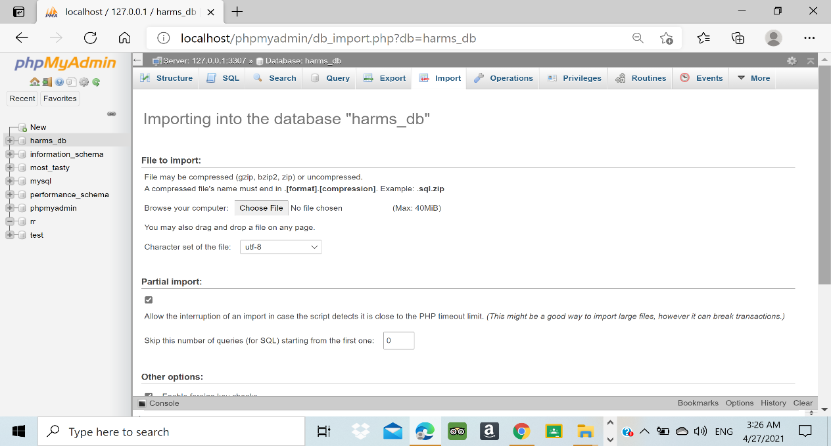🡪Click to "Choose File"

🡪Navigate and select " harms_db.sql" file

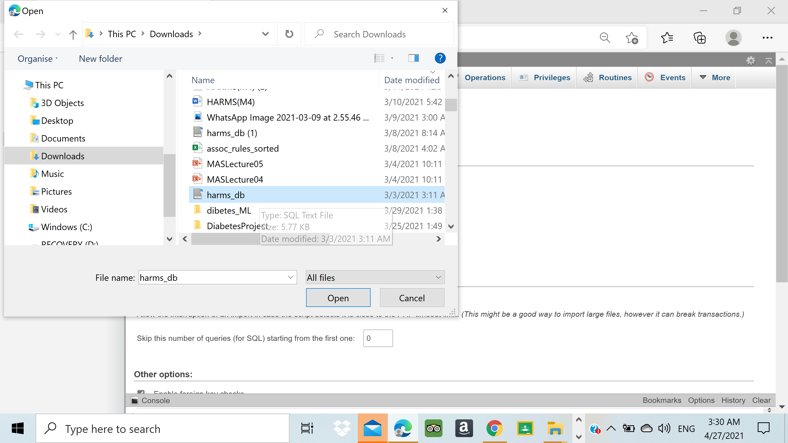

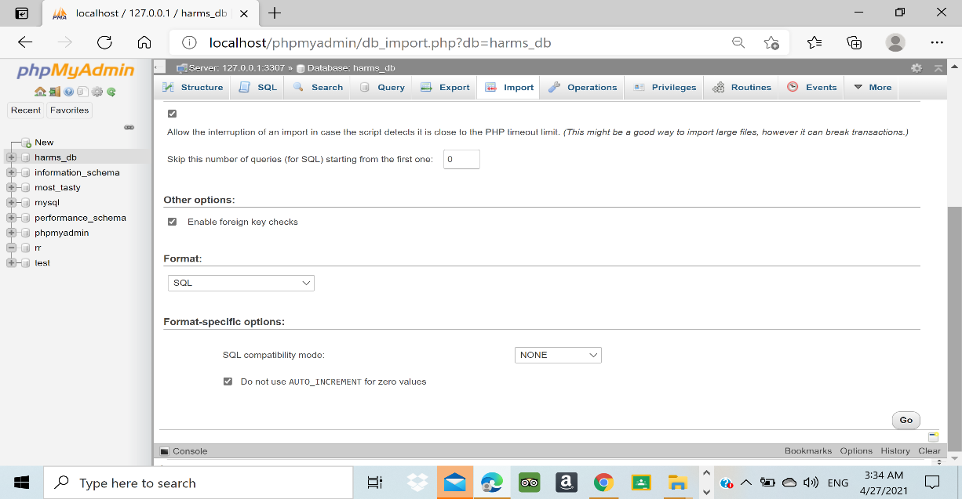🡪Click go

**3.Run the project**

**A. Run the "HARMS_Project" file**

🡪make sure you started the Apache and MySQL at " xampp-control".

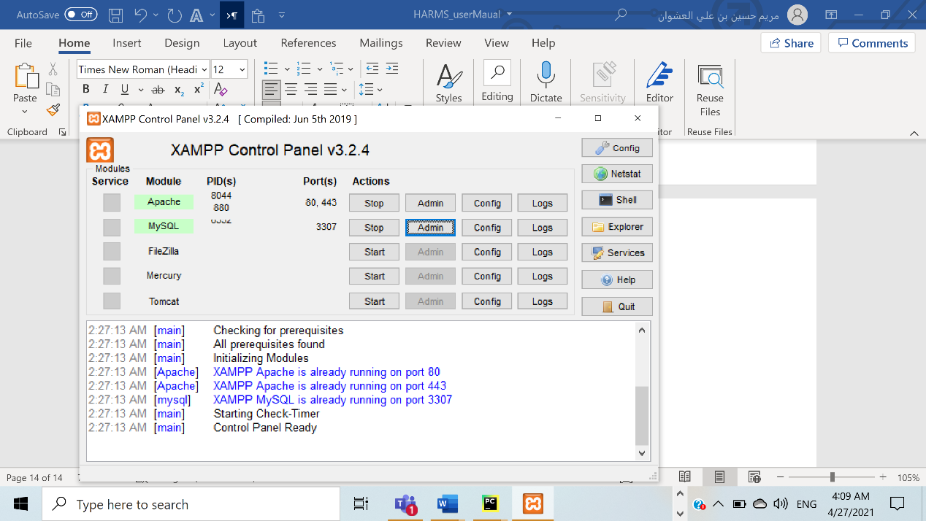

🡪Go to any browser and write "https://localhost/HARMS_Project/" in the search bar and click "Enter".

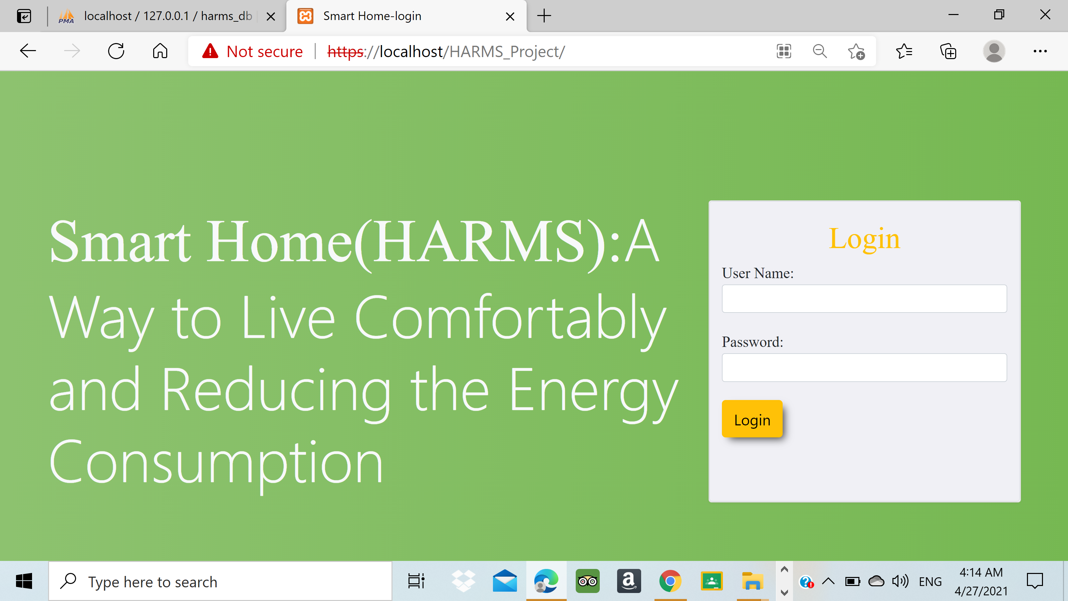

Important Note!!

To enter the dashboard for the first time: the user needs to enter the fixed username "Admin" and the default password " Sam*Nab*Mar". Then, the system will ask the user to change the password.

**B. Run the Simulation**

🡪Download the simulation web page and located in xampp htdcos folder then open the vs code to view the code or open the browser type "localhost" following with project name.

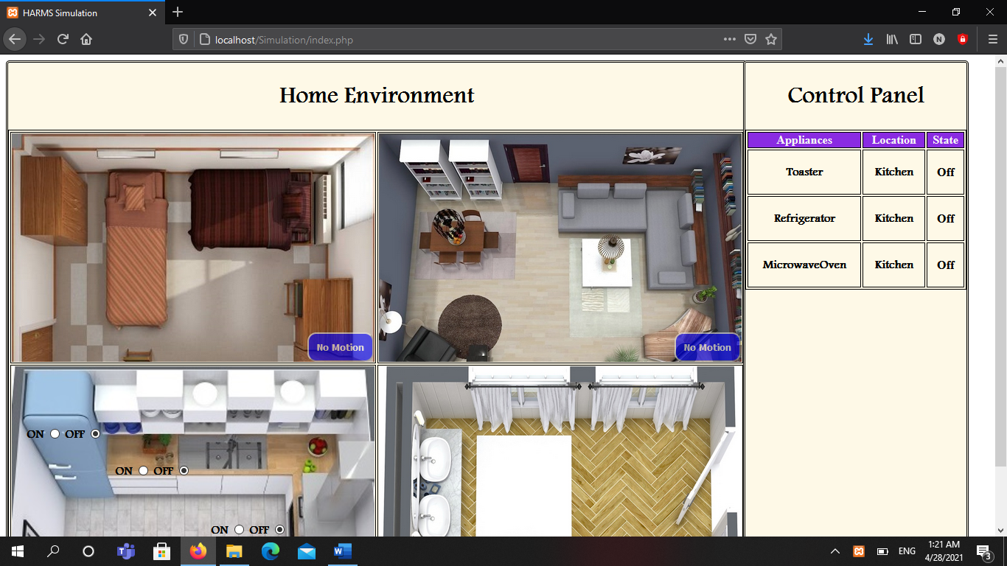

🡪Download the app project with located the php code in xampp 🡪 htdocs the open android studios.

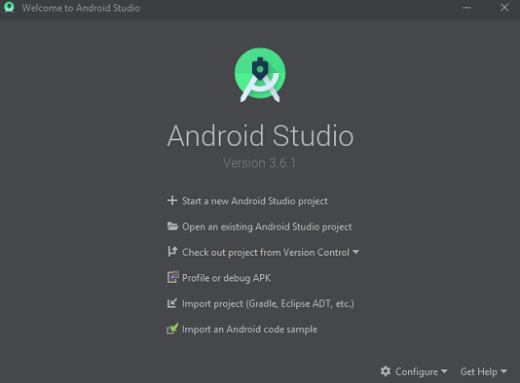

🡪Click open Android project and select the harms project then run the project after download the apk and api you will get the mobile app

🡪Do not forget to change the ip address in mainactivity, dashboard and pattern classes to your devices ip

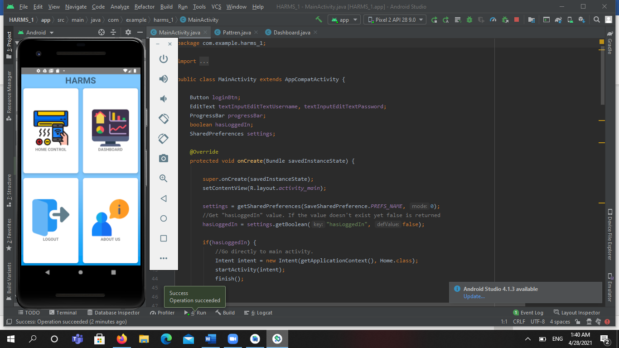

Regarding hardware connect the devices together

Download the python code and run it